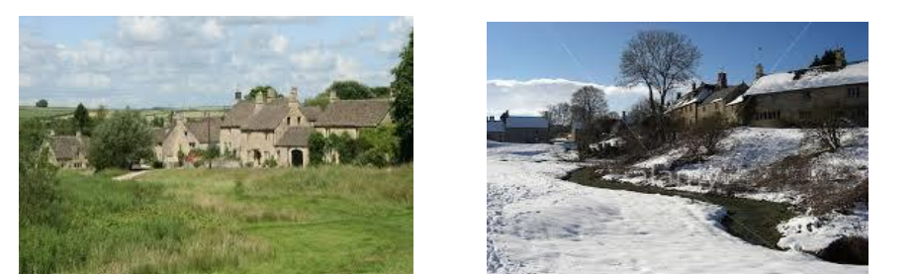

‘Strim, Stream and Soup’ Little Barrington Village Green
Saturday 26 September 2026 – 10.00 onwards
In the ancient Cotswold village of Little Barrington,
Is a green and a stream, with bench to sit upon,
The nettles and weeds are too high
And with winter drawing nigh
We need your help in a clearing and strimathon !

We would be most grateful for your help as we give The Green its annual autumn ‘haircut’ and clear the Stream. Please come and support us bringing any of the following, or just yourself:
• Strimmers
• Cutters or Slashers
• Rakes or Shovels
• Gloves & Wellies
• Coffee or Tea
• or perhaps a course or liquid refreshment for lunch

